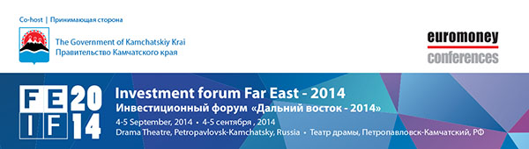
Complimentary Invitation
Dear Sir/ Madam,
Euromoney is delighted to invite you to the Kamchatka Investment Forum: Far East 2014 which will be held on 4-5 September in Petropavlovsk-Kamchatsky, Russia.
With Russia's pivot to East Asia and the recent announcement of the Russia-China gas pipeline, this event will be the first major investment forum to bring together North East Asia, Europe and Far East Russia.
The strategic and commercial importance of the resourceful Kamchatka region is undeniable. Situated at the cross roads between the Northern Pacific Rim and Europe, the Kamchatka region has a compelling story to tell about the extensive experience of cooperation with foreign companies who are already investing heavily in the region’s economy (specifically China, Japan and Korea).
This forum is free to participate and by invitation only. Supported by the Government of Kamchatka Krai and the federal Ministry of Development of the Far East, the key theme will be to showcase Russia’s increasing focus in developing the Far East region together with Europe and Asia Pacific.
Click here to view a geographical map of the Kamchatka region.
Topics:
> Far East of Russia – on the cross roads between Europe and Asia Pacific?
> Far East integration into the world economy
> The Future of Far East Russia and Asia: Cooperation, Opportunities and Challenges
> Financing case studies
> Energy potential
> Shipping, transport and logistics
> Natural resources
> Mining and commodities
> Agribusiness and fisheries
> Growth of sports and tourism
In addition, workshops will showcase projects that are open for investments and JVs.
Over 300 senior executives from many industries, investors, bankers and policymakers from across Europe, regional Russia and Asia Pacific will be in attendance offering attendees a unique networking opportunity. Simultaneous interpretation will be available in English and Russian.
It’s quite a remote place, but very beautiful and we are excited to deliver a successful conference there. As an attendee you will be further invited to cultural performances and tours before and after the forum.
Click here for the latest agenda.
Some of the speakers confirmed so far include:
Yuri P. Trutnev, Deputy Prime Minister, Presidential Envoy to the Far Eastern Federal District, Government of the Russian Federation
Alexander S. Galushka, Minister for Development of the Far East, Government of the Russian Federation
Vladimir I. Ilyukhin, Governor, Kamchatka Krai
Daniel Broby, Chief Investment Officer, Silk Invest
Joseph C. F. Lufkin, Executive Director, IFCL Group
William Pesek, Columnist, Bloomberg View
Christopher Garnett, Director, Euromoney Conferences
Florian Schmidt, Managing Director, Asia, ING Bank
Martin Lee-Warner, Senior Adviser, Raiffeisen Bank International
Hans-Martin Aerts, Head of Infrastructure Asia, APG Asset Management
For further information about the event or travel advice please reply to this e-mail or call us in Hong Kong at +852 2842 6961 (English, Russian, Chinese).
Apply for your free *place now to meet with your peers and your clients in Kamchatka.
1) Apply online inserting your promotion code SSDM2
2) Download the application form and return it to us by fax or email
3) Email your name, job title and company details to us rsvp@euromoneyasia.com, quoting your promotion code SSDM2
If you do not wish to attend, please email me here so I may remove your name from the invitation distribution list.

If you would prefer not to receive any further emails from Euromoney Institutional Investor PLC, please click here.
By opting out of this programme, you will no longer benefit from receiving information on new products and special offers from Euromoney Institutional Investor PLC.
This communication is from Euromoney Trading, a company registered in England and Wales under company number 954730 with registered office at Nestor House, Playhouse Yard, London EC4V 5EX, UK.

